**8 SCIENCE ENERGY EFFICIENCY ASSIGNMENT**

[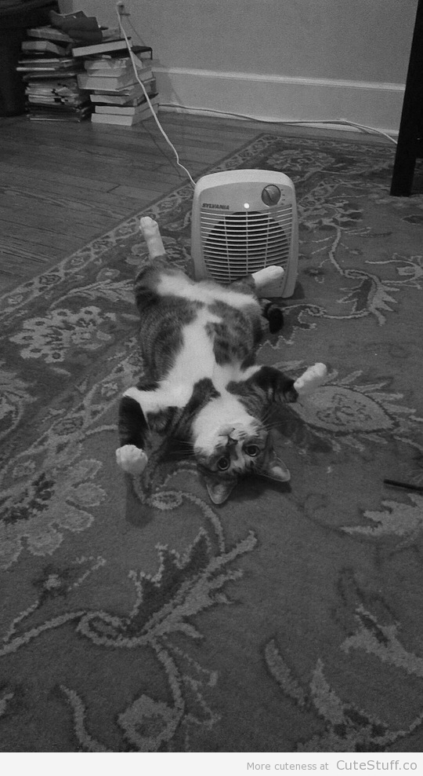](http://www.google.com.au/url?sa=i&rct=j&q=cat+energy+efficient&source=images&cd=&cad=rja&uact=8&docid=ivsTDEQK48Y_OM&tbnid=4-pH1Rv2FuCoKM:&ved=0CAYQjRw&url=http://cutestuff.co/2013/02/cat-loves-heater/&ei=Q1wpU4vaJYnbkAXQsYGgBQ&psig=AFQjCNGfNkyt67rC-AxndFBpmE3WqdfEsA&ust=1395305910912376)

Name:_________________ Teacher:____________

Form:_________________ Due date:___________

**Aim:** to investigate different ways to improve energy efficiency in the home.

**IMPORTANT INFORMATION**

**Plagiarism**

•This assignment is to be done individually, not with a partner.

•You must write in your own words not copy sentences word for word from another student or another source.

•Plagiarising = instant zero on assignment and you will have to re-do it.

**Referencing**

•You must reference your information, see your diary for instructions.

•Include a minimum of 2 references.

**How to reference a web site:**

Rice, C. (2013). Retrieved February 8, 2014 from [www.bbc.co.uk/news/technology-25103362](http://www.bbc.co.uk/news/technology-25103362)

Author’s last name, first letter of first name. (Year of publication). Date you retrieved the information, website

**Presentation**

•Neat writing (if you struggle with this, type your information).

•Correct spelling, grammar and full sentences.

**Assessment policy**

Have sick note/legitimate reason from parent = new negotiated due date.

Assignment not submitted on due date and no sick note from parents = -20% mark

Assignment not submitted on new negotiated due date = -40% mark

+ Letter home to parents

+ Must attend academic completion to complete assignment

**OR**

Submit assignment to student services before academic completion date and academic completion not necessary.

Academic completion not attended = zero on assignment + Saturday detention

**If you know that you cannot submit your assignment on the due date, let your teacher know BEFORE the due date (email them if you are not in school) or just email them your assignment the night before.**

**SECTION 1: ANALYSE THE HOME**

**1. On the picture of the house below, mark clearly six situations where energy is not being used efficiently.** Place a number (1-6) and colour the number in highlighter so it can be clearly seen.

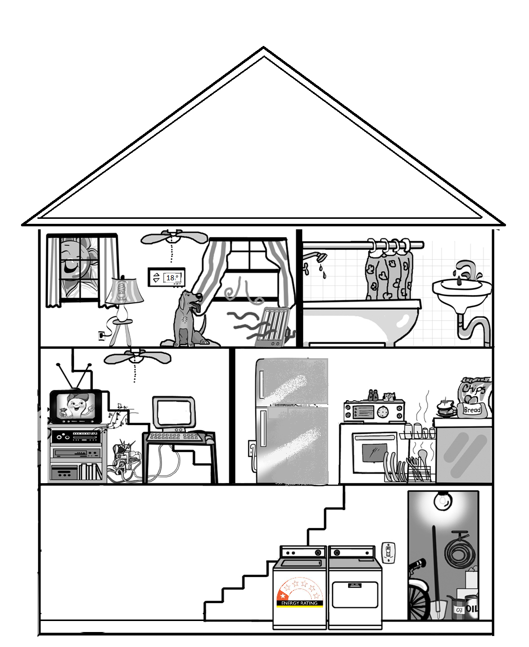

**2. In the table below, next to each number, describe how energy is not being used efficiently and describe how you could make the situation more energy efficient.**  (12 marks)

|  |  |  |
| --- | --- | --- |
| Situation  number | Describe how energy is not being used  efficiently or is being wasted | Describe how you could make the situation more  energy efficient and waste less energy |
| 1 |  |  |
| 2 |  |  |
| 3 |  |  |
| 4 |  |  |
| 5 |  |  |
| 6 |  |  |

**SECTION 2: READ ARTICLE THEN ANSWER QUESTIONS**

**Home Insulation**

Heat naturally flows from regions of higher temperature to regions of lower temperature. When you use heating to warm up the living area of your home in winter, this warm air will flow through any cracks or gaps in walls to the cool air outside. Heat can also flow up into the roof space, or through walls into a garage. This means that people need to use a lot of energy to keep a house warm in winter.

In summer, the warm air outside will naturally flow into a cool house. People need to use a lot of energy to cool their homes.

Insulation is material that can be added in ceilings and between the walls of a home to reduce heat flow. If heat flow is reduced, the energy costs to heat and cool a home are reduced. The following fact sheet produced by the Queensland Government explains what types of insulation are available.

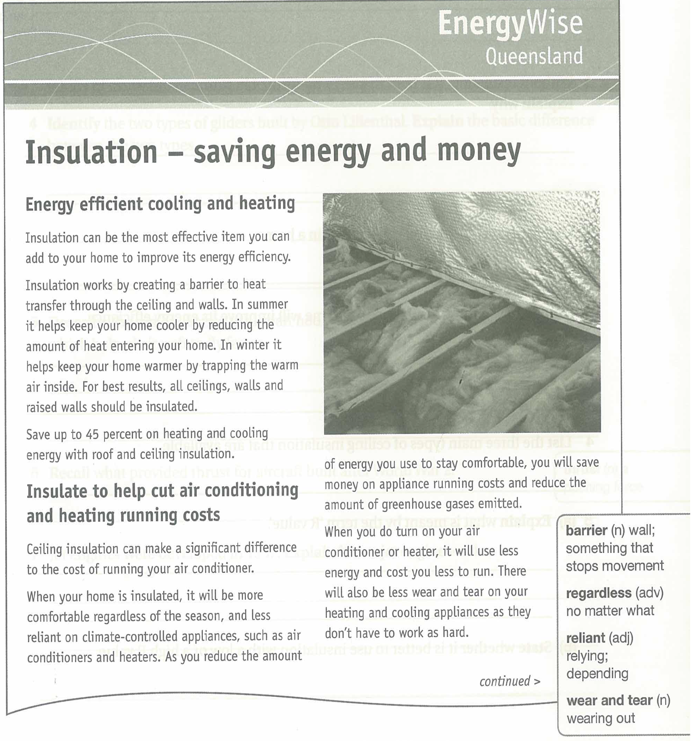

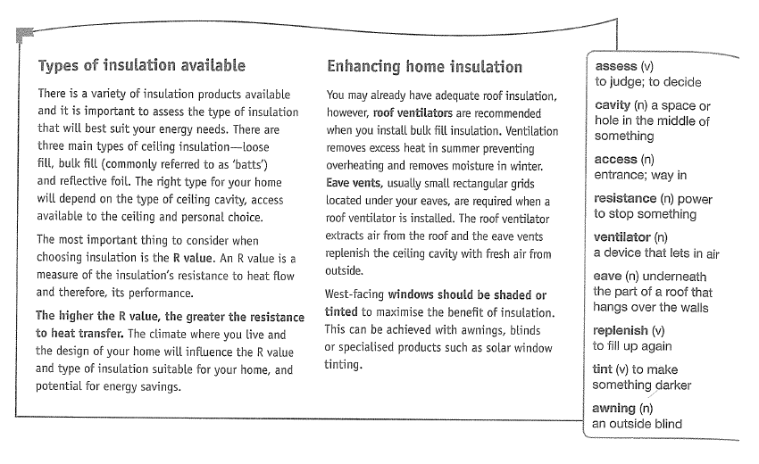

*Answer the questions based on the information above.*

**1. Without insulation, it is hard to keep a home cool in summer and warm in winter. Explain why.**

(At least two sentences) (2 marks)

_________________________________________________________________________________________________

_________________________________________________________________________________________________

_________________________________________________________________________________________________

_________________________________________________________________________________________________

_________________________________________________________________________________________________

_________________________________________________________________________________________________

**2. List three places that insulation can be used in a home.**  (3 marks)

_________________________________________________________________________________________________

_________________________________________________________________________________________________

_________________________________________________________________________________________________

_________________________________________________________________________________________________

**3. Explain how adding insulation to a home will improve its energy efficiency** (at least two sentences). (2 marks)

_________________________________________________________________________________________________

_________________________________________________________________________________________________

_________________________________________________________________________________________________

_________________________________________________________________________________________________

_________________________________________________________________________________________________

**4. List the three main types of ceiling insulation that are available.**  (3 marks)

_________________________________________________________________________________________________

_________________________________________________________________________________________________

_________________________________________________________________________________________________

_________________________________________________________________________________________________

**5. Explain what is meant by the term ‘R value’** (at least two sentences). (2 marks)

_________________________________________________________________________________________________

_________________________________________________________________________________________________

_________________________________________________________________________________________________

_________________________________________________________________________________________________

_________________________________________________________________________________________________

_________________________________________________________________________________________________

**6. State whether it is better to use insulation with a low or a high R value.** (1 mark)

_________________________________________________________________________________________________

_________________________________________________________________________________________________

**SECTION 3: ONLINE RESEARCH**

**Choose two of the following energy saving home features then answer the questions below.**

•Double glazed windows •Gas hot water system •Solar panels

•Compact fluorescent lights • Front loader washing machine

Websites to use: [livinggreener.gov.au](http://livinggreener.gov.au) <synergy.net.au> ee.ret.gov.au/energy-efficiency/homes

**1a) Energy saving feature:** __________________________________________________________________________

**b) Where is this feature used in the home?**  (1 mark)

_________________________________________________________________________________________________

**c) Find an estimate how much it will cost to put in the home** (look at websites that sell the item in Australia).(1 mark)

_________________________________________________________________________________________________

_________________________________________________________________________________________________

**d) Describe how this feature saves energy** (at least two sentences). (2 marks)

_________________________________________________________________________________________________

_________________________________________________________________________________________________

_________________________________________________________________________________________________

_________________________________________________________________________________________________

_________________________________________________________________________________________________

_________________________________________________________________________________________________

**e) Describe how widely used this feature is in Australia?** (How common is it in households in Australia) (2 marks)

(at least two sentences).

_________________________________________________________________________________________________

_________________________________________________________________________________________________

_________________________________________________________________________________________________

_________________________________________________________________________________________________

_________________________________________________________________________________________________

**2a) Energy saving feature:** __________________________________________________________________________

**b) Where is this feature used in the home?**  (1 mark)

_________________________________________________________________________________________________

**c) Estimate how much it will cost to put in the home** (look at websites that sell the item in Australia). (1 mark)

_________________________________________________________________________________________________

_________________________________________________________________________________________________

**d)** **Describe how this feature saves energy** (at least two sentences). (2 marks)

_________________________________________________________________________________________________

_________________________________________________________________________________________________

_________________________________________________________________________________________________

_________________________________________________________________________________________________

_________________________________________________________________________________________________

_________________________________________________________________________________________________

**e)** **Describe how widely used this feature is in Australia?** (How common is it in households in Australia) (2 marks)

(at least two sentences).

_________________________________________________________________________________________________

_________________________________________________________________________________________________

_________________________________________________________________________________________________

_________________________________________________________________________________________________

_________________________________________________________________________________________________

**References**  (2 marks)

_________________________________________________________________________________________________

_________________________________________________________________________________________________

_________________________________________________________________________________________________

_________________________________________________________________________________________________

_________________________________________________________________________________________________

_________________________________________________________________________________________________

_________________________________________________________________________________________________

_________________________________________________________________________________________________

_________________________________________________________________________________________________

_________________________________________________________________________________________________

_________________________________________________________________________________________________

_________________________________________________________________________________________________

_________________________________________________________________________________________________

_________________________________________________________________________________________________

_________________________________________________________________________________________________

_________________________________________________________________________________________________

_________________________________________________________________________________________________

_________________________________________________________________________________________________

**Grammar and spelling**  (1 mark)

Mark: /40 Percentage: %

**Teacher’s comments:**

_________________________________________________________________________

_________________________________________________________________________

_________________________________________________________________________